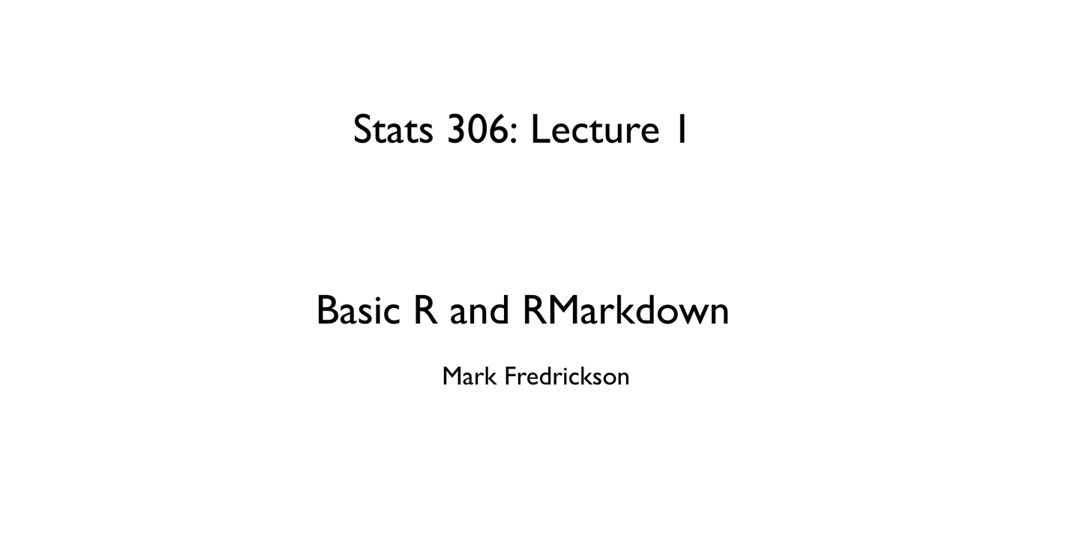

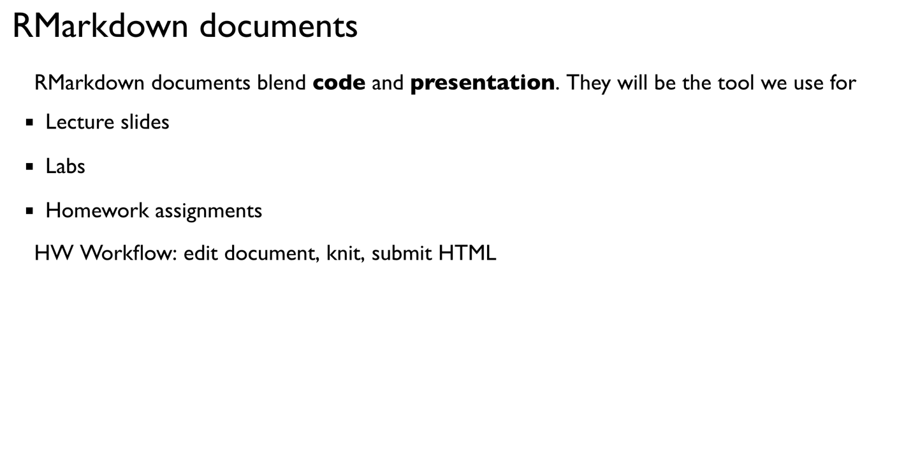

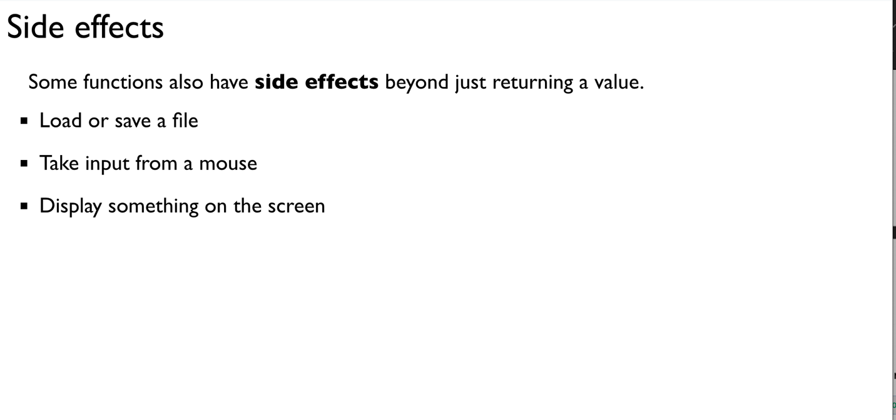

output: 777

